Holy Trinity Lutheran Church (ELCA)
605 Madison St., Marshall WI 53559
Rev. Nancy M. Raabe, pastor – Carol Johnson-Hohol, organist
All music and texts reprinted with permission under OneLicense #A729064

Third Sunday of Lent March 15, 2020

WELCOME AND ANNOUNCEMENTS
Please stand and turn toward the font.

CONFESSION AND FORGIVENESS
Blessed be the holy Trinity, ☩ one God, who forgives all our sin,
whose mercy endures forever. Amen.

God of all mercy and consolation, come to the help of your people,
turning us from our sin to live for you alone. Give us the power of your
Holy Spirit that we may confess our sin, receive your forgiveness, and
grow into the fullness of Jesus Christ, our Savior and Lord.
Let us confess our sin in the presence of God and of one another.

Most merciful God,
we confess that we are captive to sin and cannot free ourselves.
We have sinned against you in thought, word, and deed, by what we
have done and by what we have left undone.
We have not loved you with our whole heart;
we have not loved our neighbors as ourselves.
For the sake of your Son, Jesus Christ, have mercy on us.
Forgive us, renew us, and lead us, so that we may delight in your will
and walk in your ways, to the glory of your holy name. Amen.

In the mercy of almighty God, Jesus Christ was given to die for us and,
for his sake God forgives all our sins. As a called and ordained minister of the Church of Christ, and by his authority, I therefore declare to you the entire forgiveness of all your sins,
in the name of the Father, and of the ☩ Son, and of the Holy Spirit. Amen.

GATHERING HYMN “Give Me Jesus” ELW 770

GREETING The grace of our Lord Jesus Christ, the love of God, and the communion of the Holy Spirit be with you all. And also with you.

KYRIE

Prayer of the Day
Merciful God, the fountain of living water, you quench our thirst and wash away our sin. Give us this water always. Bring us to drink from the well that flows with the beauty of your truth through Jesus Christ, our Savior and Lord, who lives and reigns with you and the Holy Spirit, one God, now and forever. Amen.

Children’s Message (9:00)

First Reading: Exodus 17:1-7

Psalm 95

Second Reading: Romans 5:1-11

GOSPEL ACCLAMATION

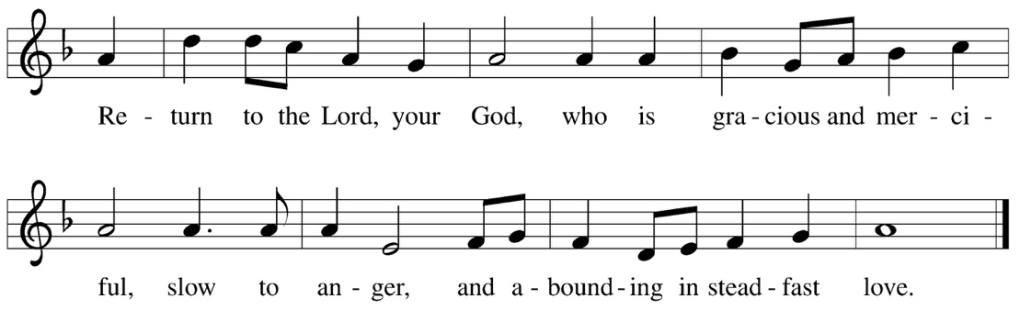

Gospel: John 4:5-42
The gospel is announced. Glory to you, O Lord.
The gospel is read. Praise to you, O Christ.

SERMON Pastor Nancy Raabe

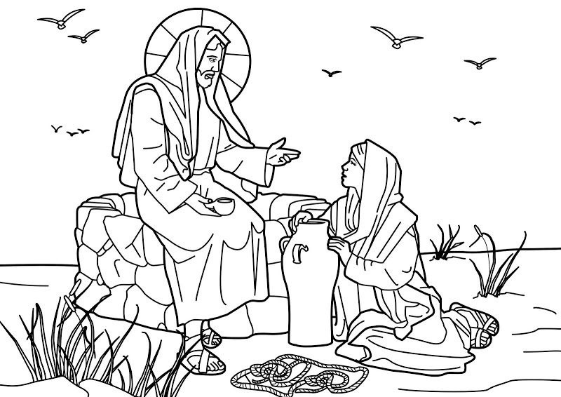

HYMN OF THE DAY “Christ, Be Our Light” ELW 715

APOSTLES’ CREED
I believe in God, the Father Almighty, creator of heaven and earth.

I believe in Jesus Christ, God’s only Son, our Lord, who was conceived by the Holy Spirit, born of the Virgin Mary, suffered under Pontius Pilate, was crucified, died, and was buried; He descended to the dead. On the third day he rose again; he ascended into heaven, he is seated at the right hand of the Father, and he will come again to judge the living and the dead.

I believe in the Holy Spirit, the holy catholic church, the communion of saints, the forgiveness of sins, the resurrection of the body, and the life everlasting. Amen.

PRAYERS OF THE PEOPLE
Turning our hearts to God who is gracious and merciful, we pray for the church, the world, and all who are in need.
Petitions end with “Hear Us, O God”
Congregation response: “Your Mercy is Great”
According to your steadfast love, O God, hear these and all our prayers as we commend them to you; through Christ our Lord. Amen.

Greeting of the Peace
The peace of Christ be with you always. And also with you.
(We share Christ’s peace with one another)

OFFERING

Offering Prayer
Holy and generous host,
you set a table where we feast as friends.
Prepare us to witness to your goodness
with every gift you have given us to share,
that all people may know your peace
through Jesus Christ, now and forever. Amen.

Dialogue
The Lord be with you.
And also with you.
Lift up your hearts.
We lift them to the Lord.
Let us give thanks to the Lord our God.
It is right to give our thanks and praise.

GREAT THANKSGIVING

It is indeed right, our duty and delight...we praise your name and join their unending hymn:

Words of Institution
“On the night in which he was betrayed….”

Lord, remember us in your kingdom and teach us to pray:

Our Father, who art in heaven, hallowed be thy name,
thy kingdom come, thy will be done, on earth as it is in heaven.
Give us this day our daily bread; and forgive us our trespasses,
As we forgive those who trespass against us;
And lead us not into temptation, but deliver us from evil.
For thine is the kingdom, and the power, and the glory,
Forever and ever. Amen.

Invitation to Communion
God’s love is poured out in Christ for you.
Open yourselves to receive it.

Lamb of God

Communion assistants, please come forward during Lamb of God

Distribution of Holy Communion (gluten-free bread)
Communion is by individual cup. Please come forward to the front step as indicated by the ushers. White grape juice is in the center ring of each tray. All are welcome.
Please indicate to an usher if you prefer to receive the sacrament in your seat.

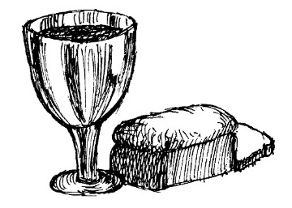
Please stand.

Prayer after Communion
We thank you, living God,
for the body and blood of your Son,
which sustains us in the wilderness and the garden alike.
As Christ has loved us in this feast,
so send us to love Christ in our neighbors.
In Jesus’ name we pray. Amen.

Blessing
Now is the acceptable time.
Now is the day of salvation.
Holy God,
speaking, spoken, and inspiring,
☩ bless you, unbind you,
and send you in love and in peace.
Amen.

Sending Hymn: “Glories of Your Name Are Spoken” LBW 358

DISMISSAL
Go in peace. Share the good news. Thanks be to God.

